Schedule

Documentation

Presentation:

Paper:

Code

Pre-Processor
  - Add preprocessor agent
    - Rules for preprocessing packets

Generator/Rendering
  - Diagram Content
    - Verifying entities
  - Appearance
    - Back loops
    - Inside images
    - Making the diagram “shorter” and more dense
    - Animations

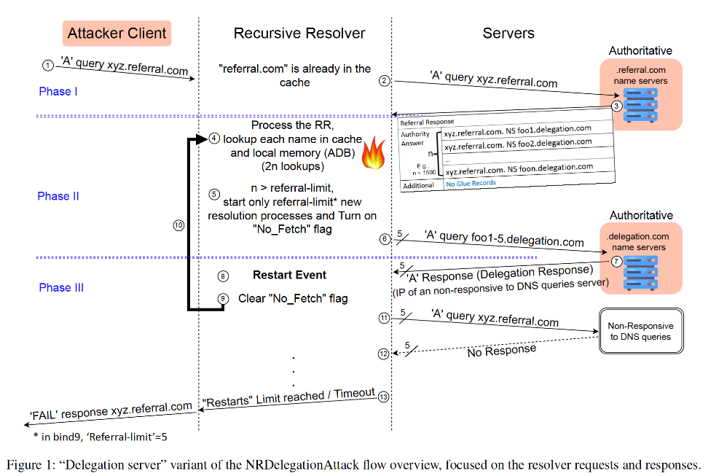
Differences between the manual and LLM:
- Different fonts for headers, content
- Cohesion: components in the LLM diagram are too far. Need to be more concise
- No inside images in the LLM diagram
- Lines are only orthogonal
- Phases headers are not clear
- No backward loops in the LLM diagram
- Step numbering shouldn’t be an emoji but a component (like the circles with numbers in the manual diagram)
  - Editing
    - Exporting to draw.io
    - Check downloading
    - Edit on site:
      - Change fonts
      - Switch images
      - Change line directions/angles

Validator

Evaluator

